SCHOOL OF COMPUTER SCIENCE AND ARTIFICIAL INTELLIGENCE |  |  |  |  | DEPARTMENT OF COMPUTER SCIENCE ENGINEERING
Program Name: B. Tech |  |  |  | Assignment Type: Lab |  |  | Academic Year:2025-2026
Course Coordinator Name |  |  |  | Venkataramana Veeramsetty
Instructor(s) Name |  |  |  | Dr. V. Venkataramana (Co-ordinator)  Dr. T. Sampath Kumar  Dr. Pramoda Patro  Dr. Brij Kishor Tiwari  Dr.J.Ravichander  Dr. Mohammand Ali Shaik  Dr. Anirodh Kumar  Mr. S.Naresh Kumar  Dr. RAJESH VELPULA  Mr. Kundhan Kumar  Ms. Ch.Rajitha  Mr. M Prakash  Mr. B.Raju  Intern 1 (Dharma teja)  Intern 2 (Sai Prasad)  Intern 3 (Sowmya)  NS_2 ( Mounika)
Course Code |  |  | 24CS002PC215 | Course Title |  | AI Assisted Coding
Year/Sem |  |  | II/I | Regulation |  | R24
Date and Day  of Assignment |  |  | Week 11 - Friday | Time(s)
Duration |  |  | 2 Hours | Applicable to  Batches
AssignmentNumber:22.5(Present assignment number)/24(Total number of assignments)
 | Q.No. | Question |  |  |  |  |  | Expected Time  to complete
 | 1 | Lab 22: Collaborative AI Coding: Pair programming and version control integration  Objective of the Lab:  The objective of this lab is to enable students to critically evaluate and address advanced ethical challenges that arise in AI-assisted coding. Students will learn to identify hidden biases, assess potential misuse, understand accountability issues, and propose safeguards to mitigate risks in real-world AI applications. This lab emphasizes decision-making in complex scenarios where technical solutions intersect with social, legal, and moral concerns.  Lab Tasks  Task 1: Bias and Fairness in AI Outputs  - Scenario: You are developing an AI code generator that assists in shortlisting candidates for a company’s technical interviews.  - Sub-Tasks:  - Evaluate how the model might introduce hidden bias based on training data (e.g., gender, college background, coding style).  - Suggest coding and dataset-level interventions to minimize such bias.  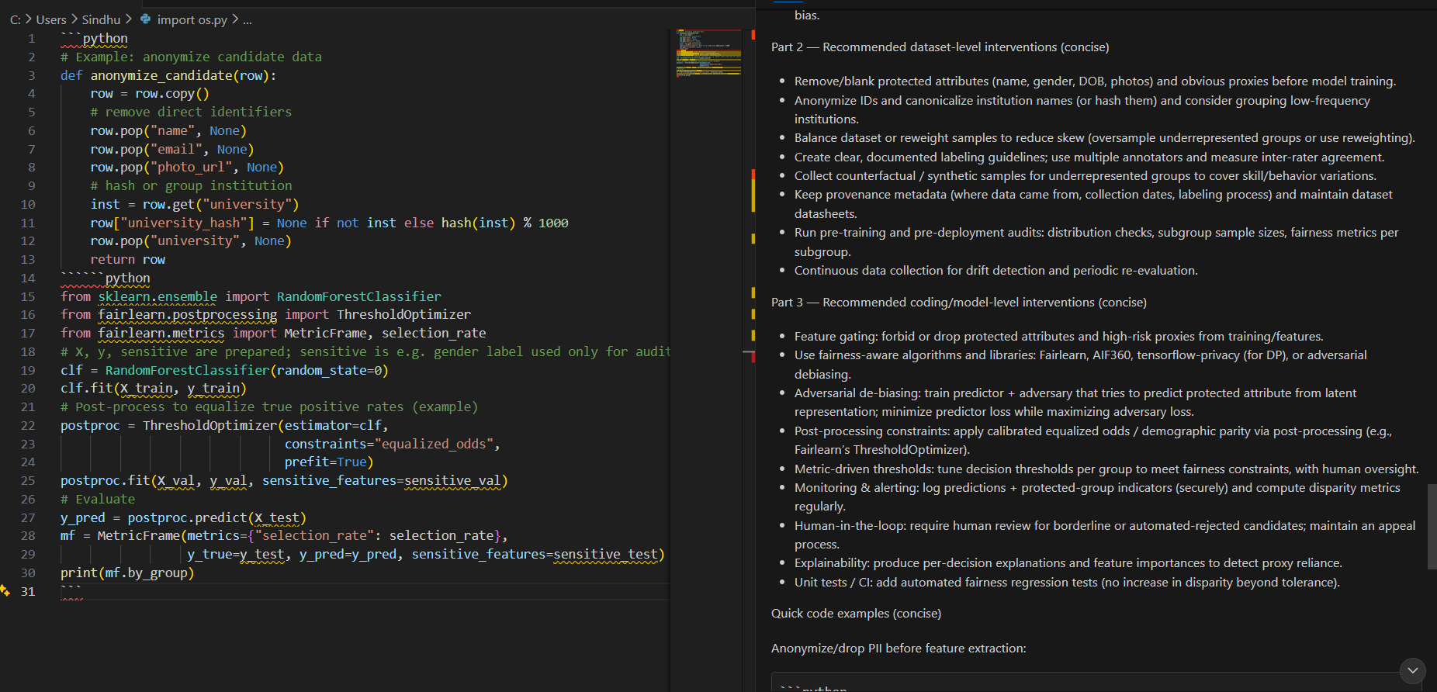  Task 2: Accountability and Responsibility  - Scenario: An AI-assisted system generates secure code for a healthcare application. Later, security vulnerability leads to a data breach.  - Sub-Tasks:  - Discuss who should be held accountable—the developer, the AI tool provider, or the organization using the tool.  - Propose a framework or coding practice that ensures traceability and accountability in AI-assisted coding workflows.  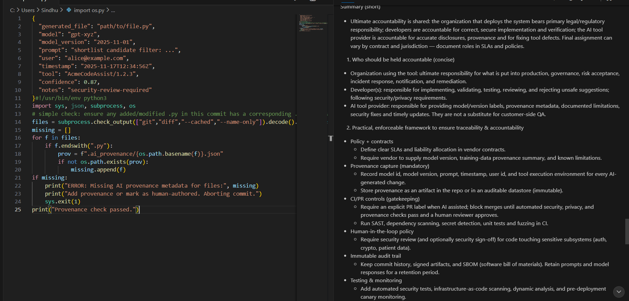  Task 3: Ethical Trade-offs and Limitations  - Scenario: You are asked to implement AI-generated code that collects user browsing data to improve a personalized recommendation system. This improves user experience but risks violating privacy.  - Sub-Tasks:  - Identify the ethical trade-offs between personalization and privacy in this scenario.  - Write guidelines or coding practices that balance user benefits with ethical safeguards (e.g., anonymization, informed consent).  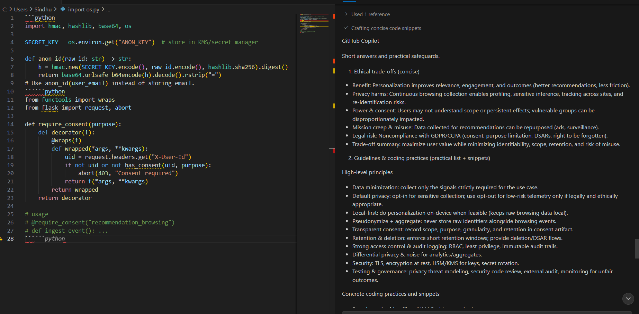  Task 4: Transparency and Explainability  - Scenario: An AI-assisted tool automatically fixes bugs in financial transaction software, but developers cannot fully explain why certain fixes are applied.  - Sub-Tasks:  - Analyze the risks of deploying AI-generated code without explainability in critical domains (e.g., finance, healthcare).  - Propose methods (e.g., logging, human-in-the-loop validation, explainable AI techniques) to improve transparency and ensure trust in the AI-assisted coding process.  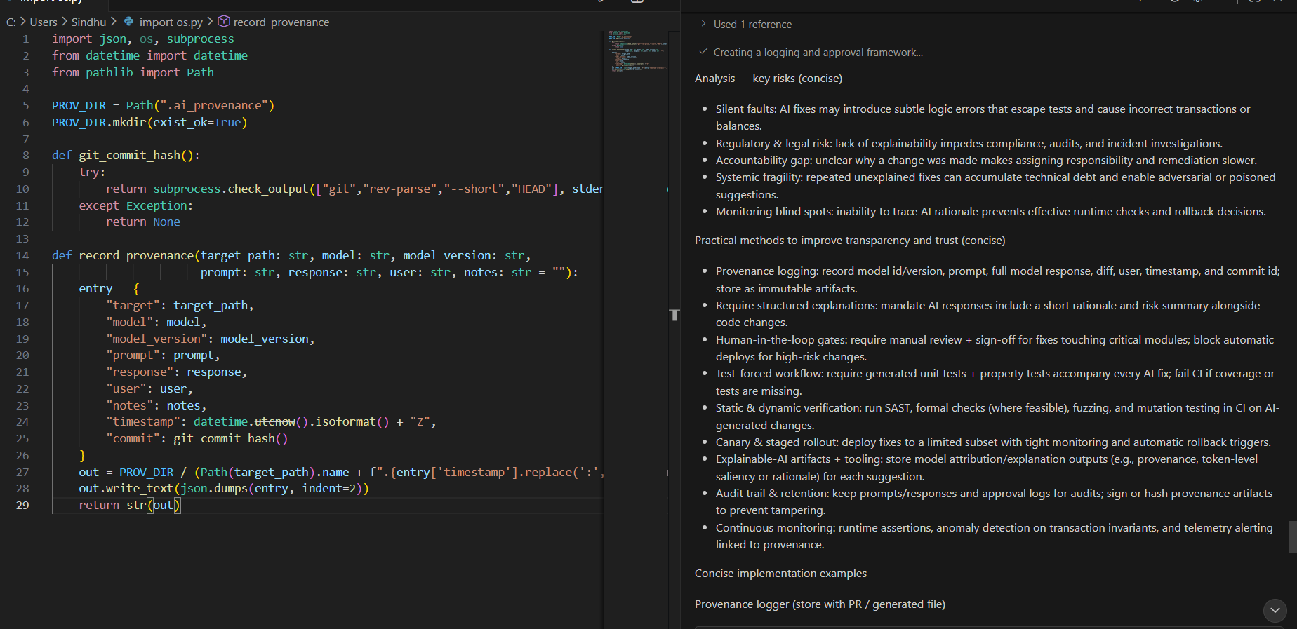 |  |  |  |  |  | Week 11 - Friday

